

**CS-2105**

**Software Engineering**

**Functional and Non-Functional Requirements**

#### **Department of Computer Science,**

**GC University Lahore**

**Submitted by: -**

**Iqra Khalique**

**Zarafshan Arjumand**

**Ayesha Yousaf**

**Section: CS-A2**

**Semester: 5th**

**Project’s Title:**

*Online Bank Management System*

**Project’s Proposal:**

This system would allow user to create an account and through that it can login. For security purposes, it requires your verified government documents. After all this, you can deposit and withdraw money. Moreover, you can send and receive money from other users as well. Further facilities include taking loan, funding any organization, donation, loan management and paying utility bills etc.

**Chosen Model:**

*XP Model*

**Activity Sequence Diagram:**

Loan Management:

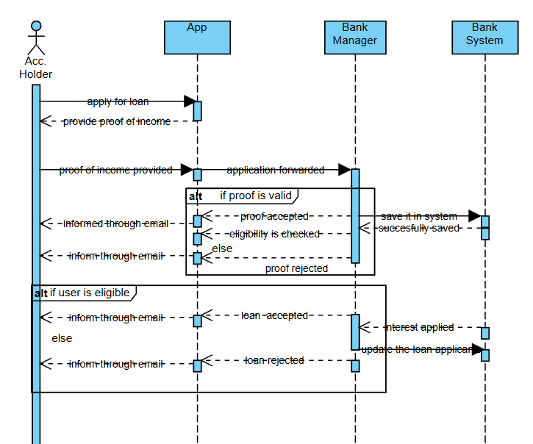

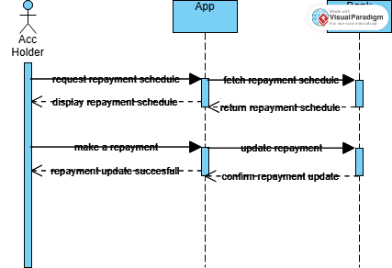

Bill Payment: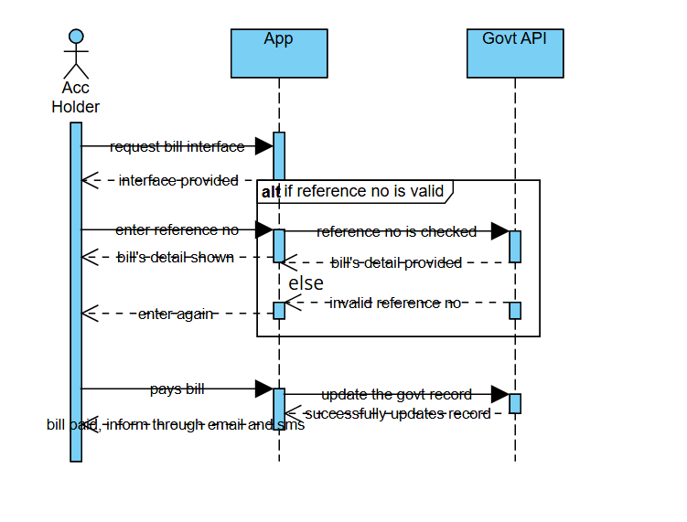

Transaction Management: